Image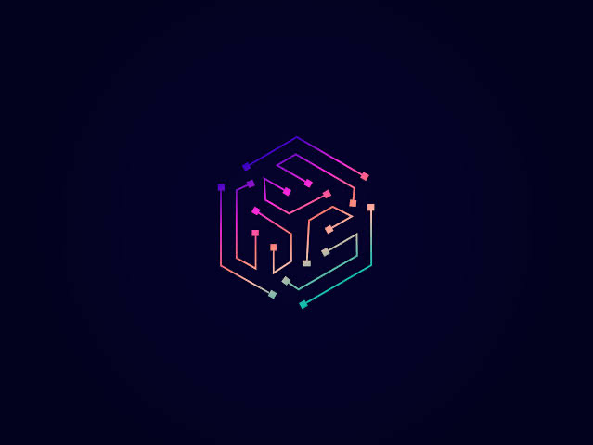

HexTech

Software Solutions Co.

CaChat

Cross-Platform Mobile Application

Pharos University in Alexandria

Mostafa Essam

Khaled Hosny

Remas Zakaria

Jasmin Khaled

Salma Mahmoud

Omar Sheriff

13 March 2022

CaChat

Is a Cross-Platform chatting Application targeting to allow users to use Real-Time chatting. Cachat is originally CAT-Chat. Since Chat is pronounced as ( cHat ) and we have a (Cat ) so we removed the T to be CaChat.

This project is Aiming to build a Co-Working Team to get ready for the Graduation project. First we are going to test the DEV-OPS in order to work in an infinite loop between developing and testing.

In order to succeed we set 7 main requirements to be ready in the " Beta version “. The main tools we are going to use are flutter and firebase .

Dev-OpsImage

As a start we are testing the software on Iphone 7 + , Samsung galaxy G7 and Huawei Y7.Once we bundle the info.plist to the Firebase we will be able to test logging in.

* Requirements:

Functional Requirements :

1- Authentication.

2- Recent conversations.

3- Picture of users or groups.

4- Activity status ( online - Last seen).

5- Search for Users.

6- Initiate conversation with user or group.

7- Real time sending & receiving

8- Online indicator